Download and Activate Office 365 on your computer
STEP1: You will find your Stride K12 email here:
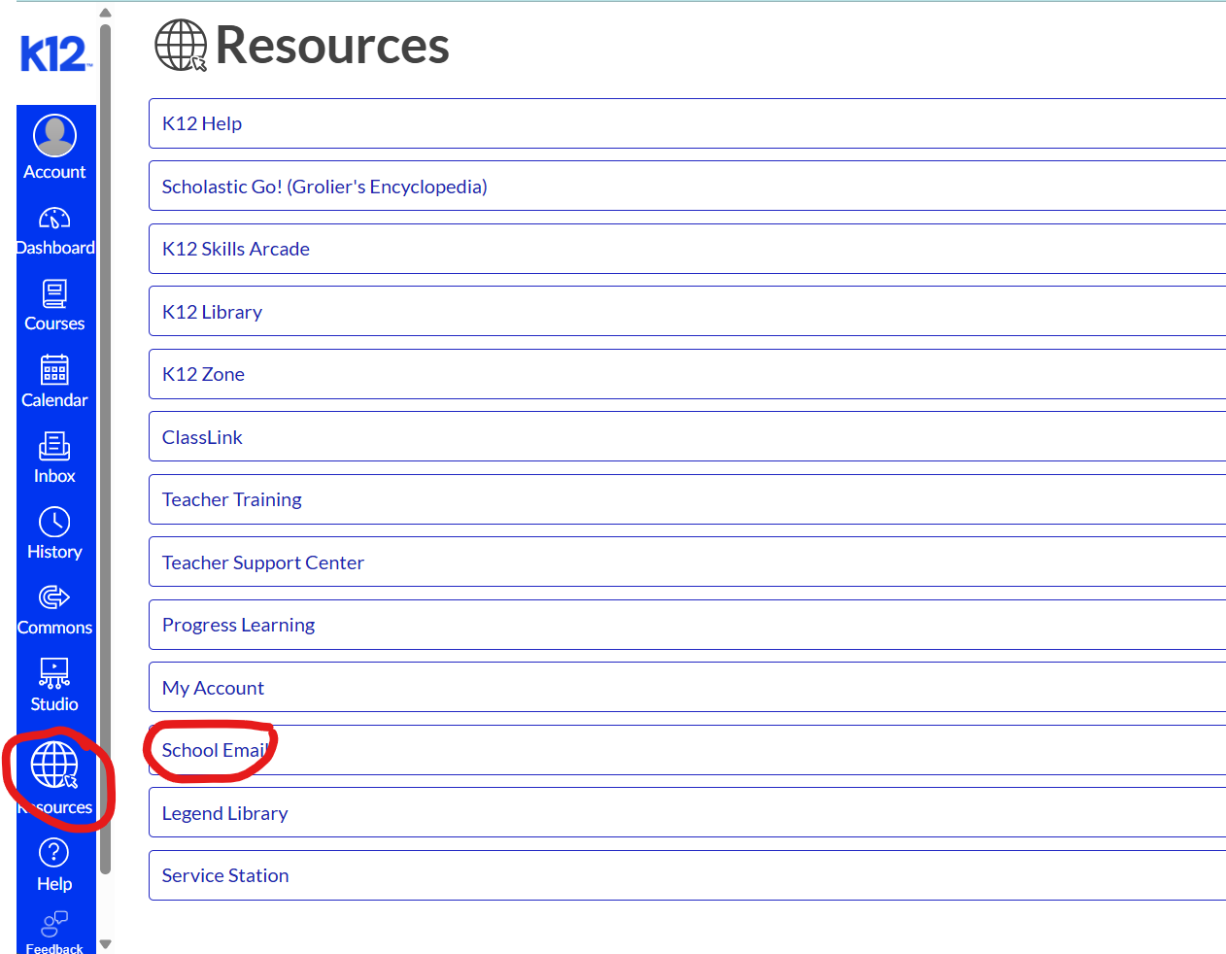
Step 2: Click on the waffle then on Office 365

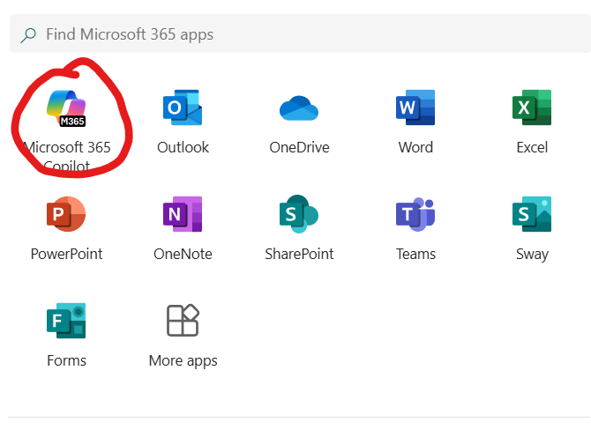
Step 3: Click Install Office 365 apps
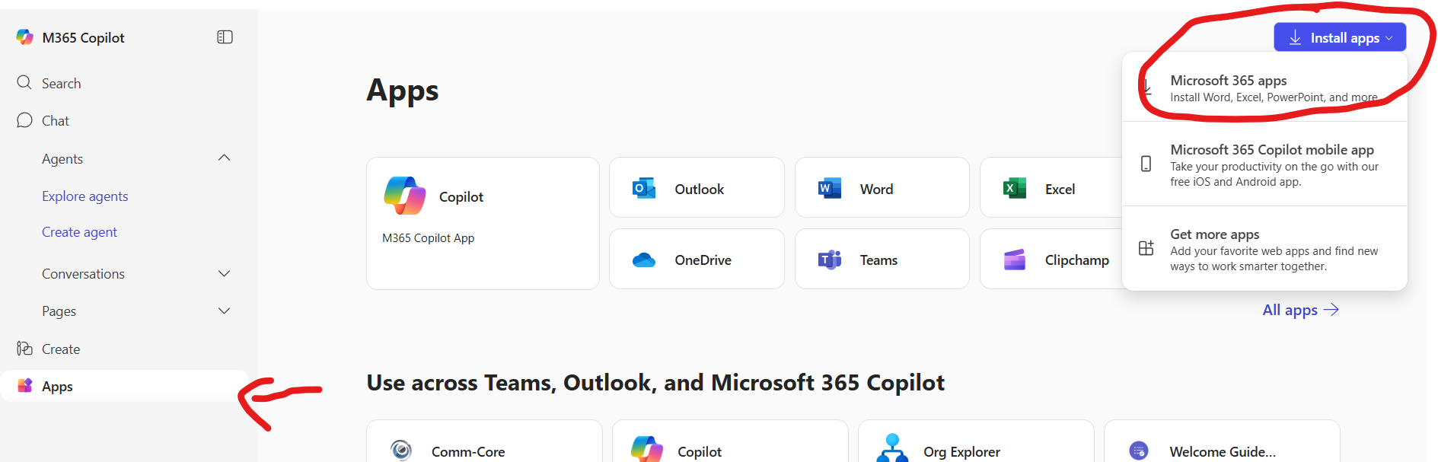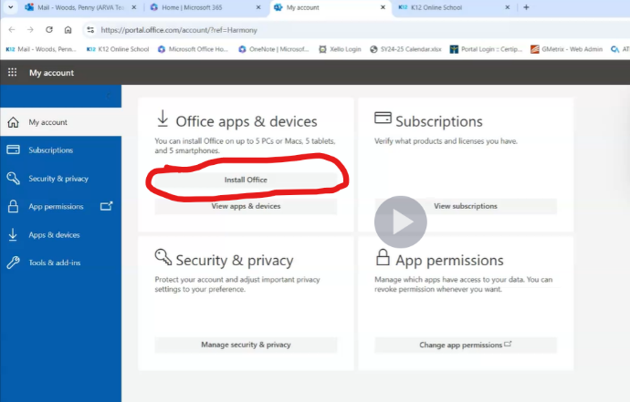
Step 4: Sign in with your ARVA email and password.

Once you download, you MUST LOG IN!(Must have your ARVA email address, user ID, and password)
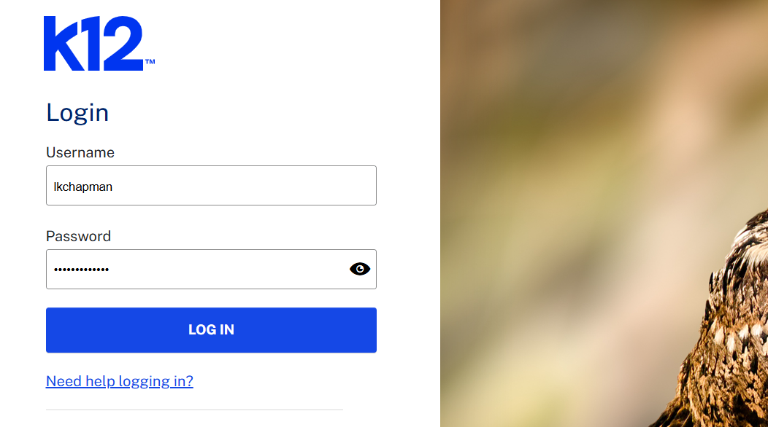
Go here to get that information (logout if you need to). Click on the eyeball to see your password

